Concurrency Control
The fundamental properties of a transaction is isolation. When several transactions execute concurrently in the database, however, the isolation property may no longer be preserved. To ensure that it is, the system must control the interaction among the concurrent transactions; this control is achieved through one of a variety of mechanisms called concurrencycontrol schemes.
There are a variety of concurrency-control schemes. No one scheme is clearly the best; each one has advantages. In practice, the most frequently used schemes are two-phase locking and snapshot isolation.

Lock Based Protocols:
Oneway to ensure isolation is to require that data items be accessed in a mutually exclusive manner; that is, while one transaction is accessing a data item, no other transaction can modify that data item. The most common method used to implement this requirement is to allow a transaction to access a data item only if it is currently holding a lock on that item.

Locks:

There are various modes in which a data item may be locked. In this section, we restrict our attention to two modes:

1. Shared. If a transaction Ti has obtained a shared-mode lock (denoted by S)
on item Q, then Ti can read, but cannot write, Q.

2. Exclusive. If a transaction Ti has obtained an exclusive-mode lock (denoted
by X) on item Q, then Ti can both read and write Q.
Every transaction has to request a lock to the concurrency-control manager in an appropriate mode on data item Q, depending on the types of operations that it will perform on Q. The transaction can proceed with the operation only after the concurrency-control manager grants the lock to the transaction.

Note: The use of these two lock modes allows multiple transactions to read a data item but limits write access to just one transaction at a time.

Example: Given a set of lock modes, we can define a compatibility function on them as follows:

Compatibility Function

Let A and B represent arbitrary lock modes. Suppose that a transaction Ti requests a lock of mode A on item Q on which transaction Tj (Ti ≠ Tj ) currently holds a lock of mode B. If transaction Ti can be granted a lock on Q immediately, in spite of the presence of the mode B lock, then we say mode A is compatible with mode B. Such a function can be represented conveniently by a matrix shown in Figure 1

Figure 1. Lock – Compatibility Matrix

An element comp(A, B) of the matrix has the value true if and only if mode A is compatible with mode B.

Note : A shared mode is compatible with shared mode, but not with exclusive mode. At any time, several shared-mode locks can be held simultaneously (by different transactions) on a particular data item. A subsequent exclusive-mode lock request has to wait until the currently held shared-mode locks are released.

Lock Request & Granting:

A transaction requests a shared lock on data item Q by executing the lock- S(Q) instruction. Similarly, a transaction requests an exclusive lock through the lock-X(Q) instruction. A transaction can unlock a data item Q by the unlock(Q) instruction.

Waiting of a Transaction:

To access a data item, transaction Ti must first lock that item. If the data item is already locked by another transaction in an incompatible mode, the concurrency control manager will not grant the lock until all incompatible locks held by other transactions have been released. Thus, Ti is made to wait until all incompatible locks held by other transactions have been released. consider again the banking example. Let A and B be two accounts that are accessed by transactions T₁and T2. Transaction T1 transfers $50 from account B to account A (Figure 1). Transaction T2 displays the total amount of money in accounts A and B (A + B) as shown in Figure 2.

T1: lock-X(B);
read(B);
B := B − 50;
write(B);
unlock(B);
lock-X(A);
read(A);
A := A + 50;
write(A);
unlock(A)

Figure 1 Transaction T1.

T2: lock-S(A);
read(A);
unlock(A);
lock-S(B);
read(B);
unlock(B);
display(A + B)

Figure 2 Transaction T2.

Suppose that the values of accounts A and B are $100 and $200, respectively. If these two transactions are executed serially, either in the order T1, T2 or the order T2, T1, then transaction T2 will display the value $300. If, however, these transactions are executed concurrently, then schedule 1, in Figure 3, is possible. In this case, transaction T2 displays $250, which is incorrect. The reason for this mistake is that the transaction T1 unlocked data item B too early, as a result of which T2 saw an inconsistent state.

Figure 3 Schedule 1

Suppose now that unlocking is delayed to the end of the transaction. Transaction T3 corresponds to T1 with unlocking delayed (Figure 4). Transaction T4 corresponds to T2 with unlocking delayed (Figure 5). You should verify that the sequence of reads and writes in schedule 1, which
lead to an incorrect total of $250 being displayed, is no longer possible with T3.

T₃: lock-X(B);
read(B);
B := B − 50;
write(B);
lock-X(A);
read(A);
A := A + 50;
write(A);
unlock(B);
unlock(A).

Figure 4 Transaction T₃ (transaction T1 with unlocking delayed).

T₄: lock-S(A);
read(A);
lock-S(B);
read(B);
display(A + B);
unlock(A);
unlock(B).

Figure 5 Transaction T₄(transaction T2 with unlocking delayed).

Unfortunately, locking can lead to an undesirable situation. Consider the partial schedule of Figure 6 for T3 and T4. Since T3 is holding an exclusive mode lock on B and T4 is requesting a shared-mode lock on B, T4 is waiting for T3 to unlock B. Similarly, since T4 is holding a shared-mode lock on A and T3 is requesting an exclusive-mode lock on A, T3 is waiting for T4 to unlock A. Thus, we have arrived at a state where neither of these transactions can ever proceed with its normal execution. This situation is called deadlock. When deadlock occurs, the system must roll back one of the two transactions. Once a transaction has been rolled back, the data items that were locked by that transaction are unlocked. These data items are then available to the other transaction, which can continue with its execution.
Figure 6 Schedule 2

If we do not use locking, or if we unlock data items too soon after reading or writing them, we may get inconsistent states. On the other hand, if we do not unlock a data item before requesting a lock on another data item, deadlocks may occur. There are ways to avoid deadlock in some situations. In general, deadlocks are a necessary evil associated with locking, if we want to avoid inconsistent states. Deadlocks are definitely preferable to inconsistent states, since they can be handled by rolling back transactions, whereas inconsistent states may lead to real-world problems that cannot be handled by the database system.

We shall require that each transaction in the system follow a set of rules, called a locking protocol, indicating when a transaction may lock and unlock each of the data items. Locking protocols restrict the number of possible schedules. The set of all such schedules is a proper subset of all possible serializable schedules.

Starvation of a Transaction :

When a transaction requests a lock on a data item in a particular mode, and no other transaction has a lock on the same data item in a conflicting mode, the lock can be granted. However, care must be taken to avoid the following scenario. Suppose a transaction T2 has a shared-mode lock on a data item, and another transaction T1 requests an exclusive-mode lock on the data item. Clearly, T1 has to wait for T2 to release the shared-mode lock. Meanwhile, a transaction T3 may request a shared-mode lock on the same data item. The lock request is compatible with the lock granted to T2, so T3 may be granted the shared-mode lock. At this point T2 may release the lock, but still T1 has to wait for T3 to finish. But again, there may be a new transaction T4 that requests a shared-mode lock on the same data item, and is granted the lock before T3 releases it. In fact, it is possible that there is a sequence of transactions that each requests a shared-mode lock on the data item, and each transaction releases the lock a short while after it is granted, but T1 never gets the exclusive-mode lock on the data item. The transaction T1 may never make progress, and is said to be starved.

Avoiding Starvation

We can avoid starvation of transactions by granting locks in the following manner: When a transaction Ti requests a lock on a data item Q in a particular mode M, the concurrency-control manager grants the lock provided that:

1. There is no other transaction holding a lock on Q in a mode that conflicts with M.

2. There is no other transaction that is waiting for a lock on Q and that made its lock request before Ti .

Thus, a lock request will never get blocked by a lock request that is made later.

The Two-Phase Locking Protocol

One protocol that ensures serializability is the two-phase locking protocol. This protocol requires that each transaction issue lock and unlock requests in two phases:

1. Growing phase. A transaction may obtain locks, but may not release any lock.

2. Shrinking phase. A transaction may release locks, but may not obtain any new locks.

Initially, a transaction is in the growing phase. The transaction acquires locks as needed. Once the transaction releases a lock, it enters the shrinking phase, and it can issue no more lock requests. (As shown in Figure 7)

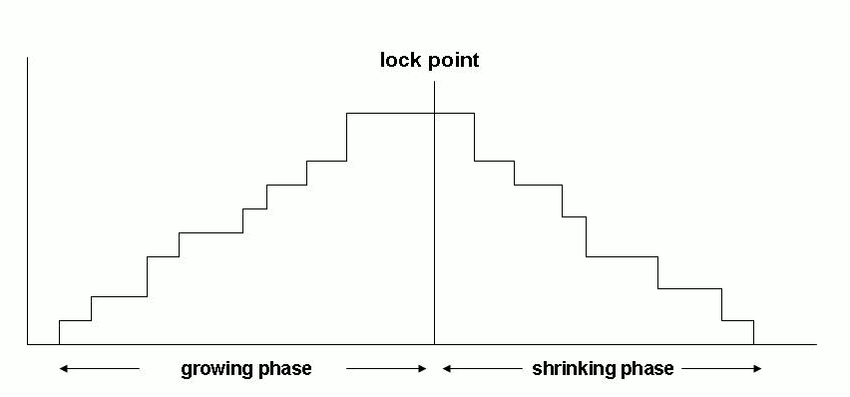
Figure 7 2- phase locking protocol

For example, transactions T₃ and T₄ (Figure 4 and Figure 5 ) are two phase. On the other hand, transactions T1 and T2 are not two phase. Note that the unlock instructions do not need to appear at the end of the transaction. For example, in the case of transaction T3, we could move the unlock(B) instruction to just after the lock-X(A) instruction, and still retain the two-phase locking property.

Two-phase locking does not ensure freedom from deadlock. Observe that transactions T3 and T4 are two phase, but, in schedule 2 (Figure 6), they are deadlocked.

Deadlock Handling

A system is in a deadlock state if there exists a set of transactions such that every transaction in the set is waiting for another transaction in the set. More precisely, there exists a set of waiting transactions {T0, T1, . . . , Tn} such that T0 is waiting for a data item that T1 holds, and T1 is waiting for a data item that T2 holds, and . . . , and Tn−1 is waiting for a data item that Tn holds, and Tn is waiting for a data item that T0 holds. None of the transactions can make progress in such a situation.

The only remedy to this undesirable situation is for the system to invoke some drastic action, such as rolling back some of the transactions involved in the deadlock. Rollback of a transaction may be partial: That is, a transaction may be rolled back to the point where it obtained a lock whose release resolves the deadlock.

There are two principal methods for dealing with the deadlock problem. We can use a deadlock prevention protocol to ensure that the system will never enter a deadlock state. Alternatively, we can allow the system to enter a deadlock state, and then try to recover by using a deadlock detection and deadlock recovery scheme. As we shall see, both methods may result in transaction rollback.
Note: Prevention is commonly used if the probability that the system would enter a deadlock
state is relatively high; otherwise, detection and recovery are more efficient.

Deadlock Prevention
There are two approaches to deadlock prevention. One approach requiring all locks to be acquired together. The other approach performs transaction rollback instead of waiting for a lock, whenever the wait could potentially result in a deadlock.

First Approach:

The simplest scheme under the first approach requires that each transaction locks all its data items before it begins execution. There are two main disadvantages to this protocol: (1) it is often hard to predict, before the transaction begins, what data items need to be locked (2) data-item utilization may be very low, since many of the data items may be locked but unused for a long time.

Another approach for preventing deadlocks is to impose an ordering of all data items, and to require that a transaction lock data items only in a sequence consistent with the ordering. A variation of this approach is to use a total order of data items, in conjunction with two-phase locking. Once a transaction has locked a particular item, it cannot request locks on items that precede that item in the ordering. This scheme is easy to implement, as long as the set of data items accessed by a transaction is known when the transaction starts execution.

Second Approach:

The second approach for preventing deadlocks is to use preemption and transaction rollbacks. To control the preemption, we assign a unique timestamp, based on a counter or on the system clock, to each transaction when it begins. The system uses these timestamps only to decide whether a transaction should wait or roll back. Locking is still used for concurrency control. If a transaction is rolled back, it retains its old timestamp when restarted. Two different deadlock-prevention schemes using timestamps have been proposed:

1. The wait–die scheme is a nonpreemptive technique. When transaction Ti requests a data item currently held by Tj , Ti is allowed to wait only if it has a timestamp smaller than that of Tj (that is, Ti is older than Tj ). Otherwise, Ti is rolled back (dies).

For example, suppose that transactions T14, T15, and T16 have timestamps 5, 10, and 15, respectively. If T14 requests a data item held by T15, then T14 will wait. If T16 requests a data item held by T15, then T16 will be rolled back.

2. The wound–wait scheme is a preemptive technique. It is a counterpart to the wait–die scheme. When transaction Ti requests a data item currently held by Tj , Ti is allowed to wait only if it has a timestamp larger than that of Tj (that is, Ti is younger than Tj ). Otherwise, Tj is rolled back (Tj is wounded by Ti ).

Returning to our example, with transactions T14, T15, and T16, if T14 requests a data itemheld by T15, then the data item will be preempted from T15, and T15 will be rolled back. If T16 requests a data item held by T15, then T16 will wait.

Another simple approach to deadlock prevention is based on lock timeouts. In this approach, a transaction that has requested a lock waits for at most a specified amount of time. If the lock has not been granted within that time, the transaction is said to time out, and it rolls itself back and restarts. If there was in fact a deadlock, one or more transactions involved in the deadlock will time out and roll back, allowing the others to proceed.

The timeout scheme is particularly easy to implement, and works well if transactions are short and if long waits are likely to be due to deadlocks. However, in general it is hard to decide how long a transaction must wait before timing out. Too long a wait results in unnecessary delays once a deadlock has occurred. Too short a wait results in transaction rollback even when there is no deadlock, leading to wasted resources. Starvation is also a possibility with this scheme. Hence, the timeout-based scheme has limited applicability.

Observation: In wait-die approach, older transaction will wait and newer (younger) transaction will die. In wound-wait approach older will wound the younger one and younger will wait.

Deadlock Detection and Recovery

Deadlock Detection:

Deadlocks can be described precisely in terms of a directed graph called a wait-for graph. This graph consists of a pair G = (V, E), where V is a set of vertices and E is a set of edges. The set of vertices consists of all the transactions in the system. Each element in the set E of edges is an ordered pair Ti → Tj. If Ti → Tj is in E, then there is a directed edge from transaction Ti to Tj , implying that transaction Ti is waiting for transaction Tj to release a data item that it needs. This edge is inserted in the wait-for graph. This edge is removed only when transaction Tj is no longer holding a data item needed by transaction Ti .

A deadlock exists in the system if and only if the wait-for graph contains a cycle. Each transaction involved in the cycle is said to be deadlocked. To detect deadlocks, the system needs to maintain the wait-for graph, and periodically to invoke an algorithm that searches for a cycle in the graph.

To illustrate these concepts, consider the wait-for graph in Figure 8, which depicts the following situation:

• Transaction T17 is waiting for transactions T18 and T19.
• Transaction T19 is waiting for transaction T18.
• Transaction T18 is waiting for transaction T20.

Figure 8 Wait-For graph with no cycle

Since the graph has no cycle, the system is not in a deadlock state.

Suppose now that transaction T20 is requesting an item held by T19. The edge T20 → T19 is added to the wait-for graph, resulting in the new system state in Figure 9. This time, the graph contains the cycle:

T18 →T20 →T19 →T18

Figure 9 Wait-For graph with cycle

implying that transactions T18, T19, and T20 are all deadlocked.

Consequently, the question arises: When should we invoke the detection algorithm? The answer depends on two factors:

1. How often does a deadlock occur?
2. How many transactions will be affected by the deadlock?

If deadlocks occur frequently, then the detection algorithm should be invoked more frequently. In the worst case, we would invoke the detection algorithm every time a request for allocation could not be
granted immediately.

Recovery from Deadlock

When a detection algorithm determines that a deadlock exists, the system must recover from the deadlock. The most common solution is to roll back one or more transactions to break the deadlock. Three actions need to be taken:

1. Selection of a victim: Given a set of deadlocked transactions, we must determine which transaction (or transactions) to roll back to break the deadlock. We should roll back those transactions that will incur the minimum cost. Many factors may determine the cost of a rollback, including:

a. How long the transaction has computed, and how much longer the transaction will compute before it completes its designated task.
b. How many data items the transaction has used.
c. How many more data items the transaction needs for it to complete.
d. How many transactions will be involved in the rollback.

2. Rollback:. Once we have decided that a particular transaction must be rolled back, we must determine how far this transaction should be rolled back. The simplest solution is a total rollback: Abort the transaction and then restart it. However, it is more effective to roll back the transaction only as far as necessary to break the deadlock. Such partial rollback requires the system to maintain additional information about the state of all the running transactions. Specifically, the sequence of lock requests/grants and updates performed by the transaction needs to be recorded. The selected transaction must be rolled back to the point where it obtained the first of these locks, undoing all actions it took after that point. The recovery mechanism must be capable of performing such partial rollbacks.

3. Starvation. In a system where the selection of victims is based primarily on cost factors, it may happen that the same transaction is always picked as a victim. As a result, this transaction never completes its designated task, thus there is starvation. We must ensure that a transaction can be picked as a victim only a (small) finite number of times. The most common solution is to include the number of
rollbacks in the cost factor.

Timestamp-Based Protocols

Timestamps

With each transaction Ti in the system, we associate a unique fixed timestamp, denoted by TS(Ti ). This timestamp is assigned by the database system before the transaction Ti starts execution. If a transaction Ti has been assigned timestamp TS(Ti ), and a new transaction Tj enters the system, then
TS(Ti ) < TS(Tj ). There are two simple methods for implementing this scheme:

- Use the value of the system clock as the timestamp; that is, a transaction’s timestamp is equal to the value of the clock when the transaction enters the system. (i.e. T1 comes at time 2:00:00 and T2 comes at 2:00:25. This arrival time is acting as a timestamp.)

- Use a logical counter that is incremented after a new timestamp has been assigned; that is, a transaction’s timestamp is equal to the value of the counter when the transaction enters the system. (i.e. Counter value can be one from 1,2,3,4,5,….,n)

The timestamps of the transactions determine the serializability order. Thus, if TS(Ti ) < TS(Tj ), then the system must ensure that the produced schedule is equivalent to a serial schedule in which transaction Ti appears before transaction Tj.

To implement this scheme, we associate with each data item Q two timestamp values:

• W-timestamp(Q) : denotes the largest timestamp of any transaction that executed write(Q) successfully.
• R-timestamp(Q): denotes the largest timestamp of any transaction that executed read(Q) successfully.

These timestamps are updated whenever a new read(Q) or write(Q) instruction is executed.

The Timestamp-Ordering Protocol

The timestamp-ordering protocol ensures that any conflicting read and write operations are executed in timestamp order. This protocol operates as follows:

1. Suppose that transaction Ti issues read(Q).

a. If TS(Ti ) < W-timestamp(Q), then Ti needs to read a value of Q that was already overwritten. Hence, the read operation is rejected, and Ti is rolled back.

b. If TS(Ti ) ≥ W-timestamp(Q), then the read operation is executed, and R-timestamp(Q) is set to the maximum of R-timestamp(Q) and TS(Ti ).

2. Suppose that transaction Ti issues write(Q).

a. If TS(Ti ) < R-timestamp(Q), then the value of Q that Ti is producing was needed previously, and the system assumed that that value would never be produced. Hence, the system rejects the write operation and rolls Ti back.

b. If TS(Ti ) < W-timestamp(Q), then Ti is attempting to write an obsolete value of Q. Hence, the system rejects this write operation and rolls Ti back.

c. Otherwise, the system executes the write operation and sets W-timestamp(Q) to TS(Ti ).

If a transaction Ti is rolled back by the concurrency-control scheme as result of issuance of either a read or write operation, the system assigns it a new timestamp and restarts it.

Example: A partial schedule for several data items for transactions with timestamps 1, 2, 3, 4, 5 for Q = X,Y,Z

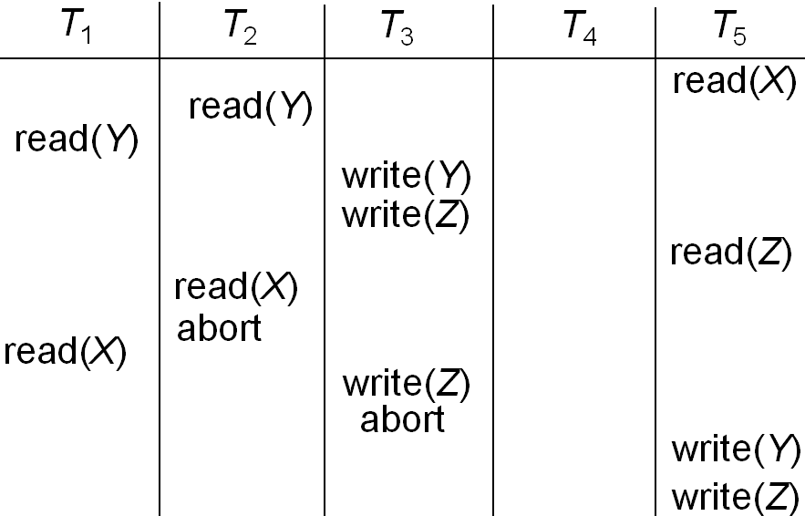
Figure 10 timestamp based schedule

Validation-Based Protocols

In optimistic concurrency control techniques, also known as validation or certification techniques, no checking is done while the transaction is executing. In this scheme, updates in the transaction are not applied directly to the database items until the transaction reaches its end. During transaction execution, all updates are applied to local copies of the data items that are kept for the transaction. At the end of transaction execution, a validation phase checks whether any of the transaction’s updates violate serializability If serializability is not violated, the transaction is committed and the database is updated from the local copies; otherwise, the transaction is aborted and then restarted later.

There are three phases for this concurrency control protocol:

1. Read phase: A transaction can read values of committed data items from the database. However, updates are applied only to local copies (versions) of the data items kept in the transaction workspace.

2. Validation phase: Checking is performed to ensure that serializability will not be violated if the transaction updates are applied to the database.

3. Write phase: If the validation phase is successful, the transaction updates are applied to the database; otherwise, the updates are discarded and the transaction is restarted.

To perform the validation test, we need to know when the various phases of transactions took place. We shall, therefore, associate three different timestamps with each transaction Ti :

1. Start(Ti), the time when Ti started its execution.
2. Validation(Ti ), the time when Ti finished its read phase and started its
validation phase.
3. Finish(Ti), the time when Ti finished its write phase.

We determine the serializability order by the timestamp-ordering technique, using the value of the timestamp Validation(Ti ). Thus, the value TS(Ti ) = Validation(Ti) and, if TS(Tj ) < TS(Tk ), then any produced schedule must be equivalent to a serial schedule in which transaction Tj appears before transaction Tk.

The validation test for transaction Ti requires that, for all transactions Tk with TS(Tk ) < TS(Ti ), one of the following two conditions must hold:

1. Finish(Tk ) < Start(Ti ). Since Tk completes its execution before Ti started, the serializability order is indeed maintained.

2. The set of data items written by Tk does not intersect with the set of data items read by Ti, and Tk completes its write phase before Ti starts its validation phase (Start(Ti ) < Finish(Tk ) < Validation(Ti )). This condition ensures that the writes of Tk and Ti do not overlap. Since the writes of Tk do not affect the read of Ti , and since Ti cannot affect the read of Tk , the serializability order is indeed maintained.

Example: Consider Transactions T25 and T26 as shown below:

T25: read(B);
read(A);
display(A + B).

Transaction T26 transfers $50 from account B to account A, and then displays the
contents of both:
T26: read(B);
B := B − 50;
write(B);
read(A);
A := A + 50;
write(A);
display(A + B)

Suppose that TS(T25) < TS(T26). Then, the validation phase succeeds in the schedule in Figure 11.
Note that the writes to the actual variables are performed only after the validation phase of T26. Thus, T25 reads the old values of B and A, and this schedule is serializable.

Figure 11 Schedule produced by Validation Protocol

The validation scheme automatically guards against cascading rollbacks, since the actual writes take place only after the transaction issuing the write has committed. However, there is a possibility of starvation of long transactions, due to a sequence of conflicting short transactions that cause repeated restarts of the long transaction.

